1. Arrival Time for the Wireshark ICMP traffic:

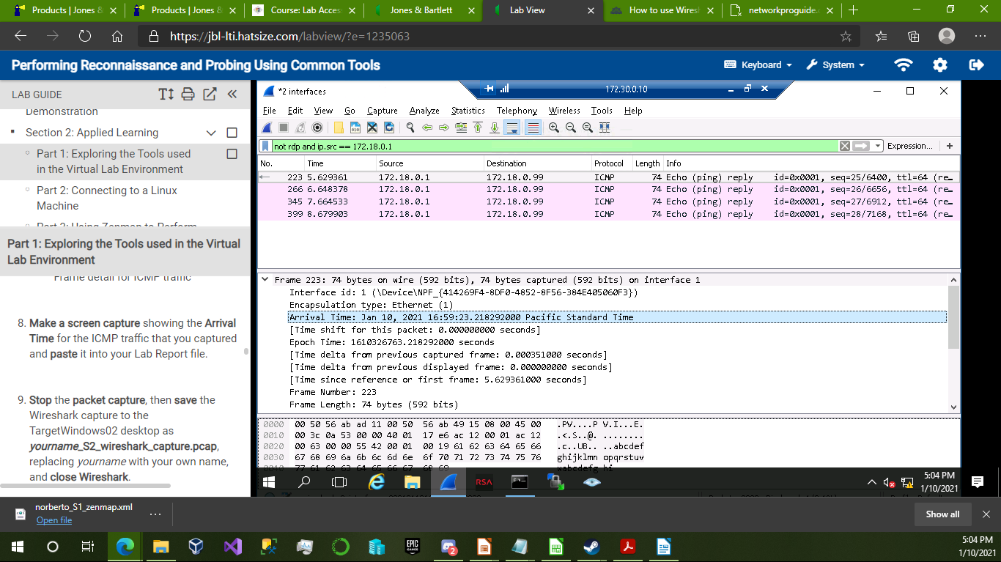

2. File details of the creditcards.txt attachment in NetWitness Investigator:

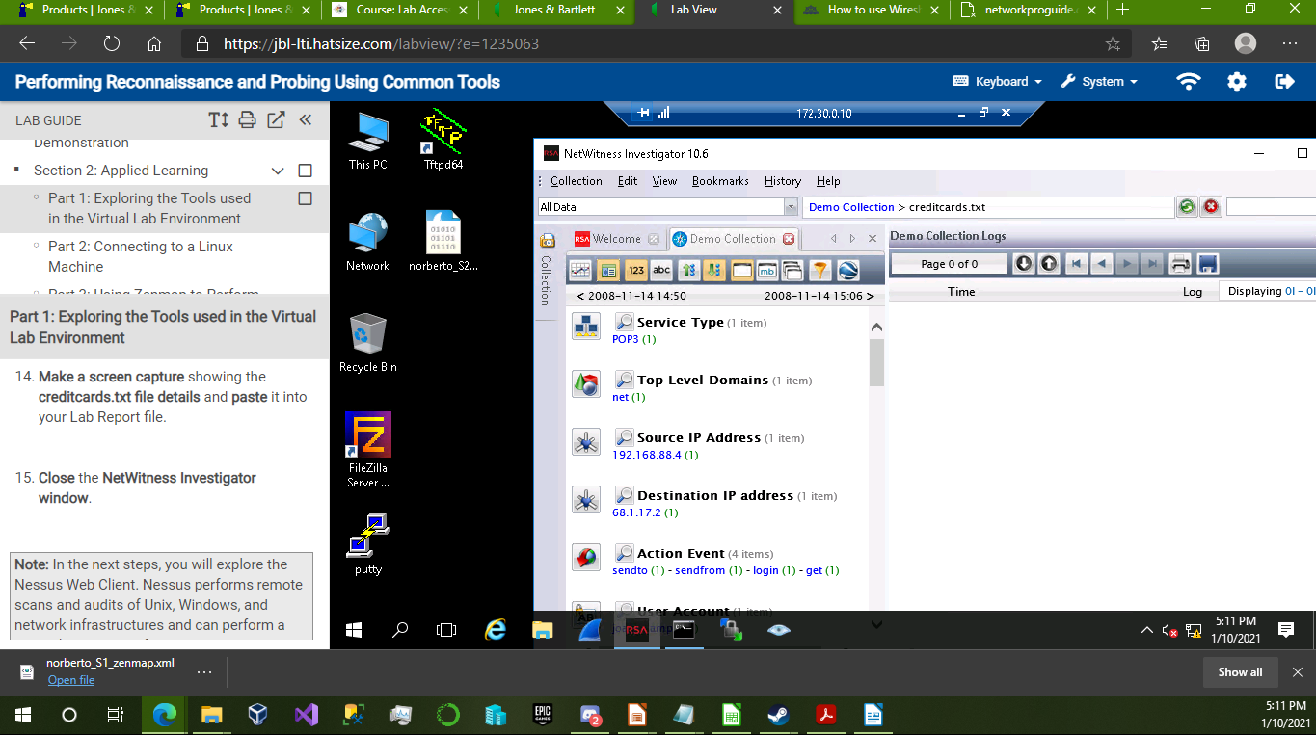

3. Nessus Vulnerability Detail Screen:

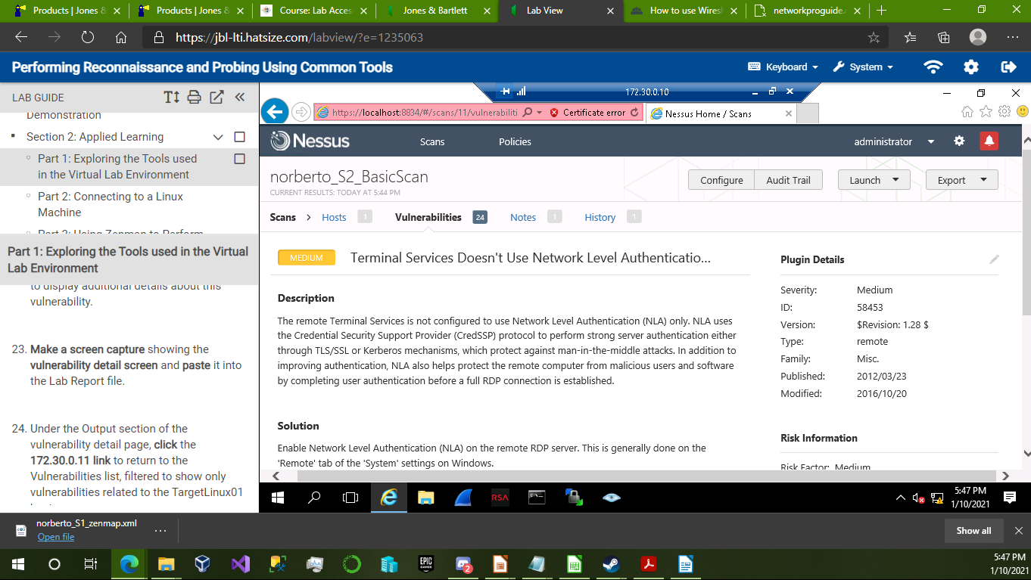

4. Successful TFTP file transfer:

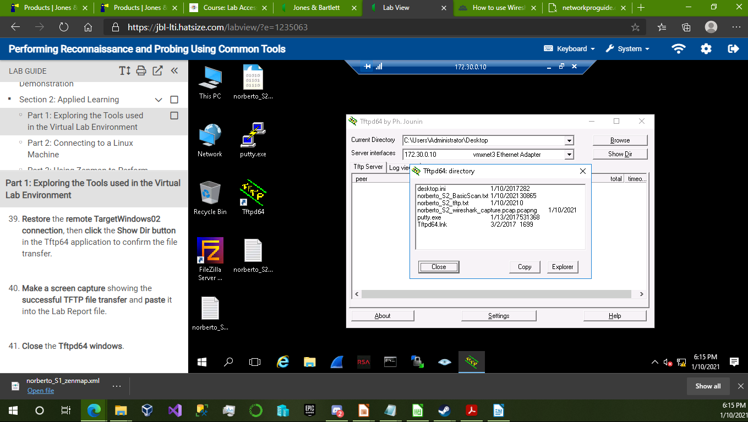

5. Output from the Cisco command issued in PuTTY:

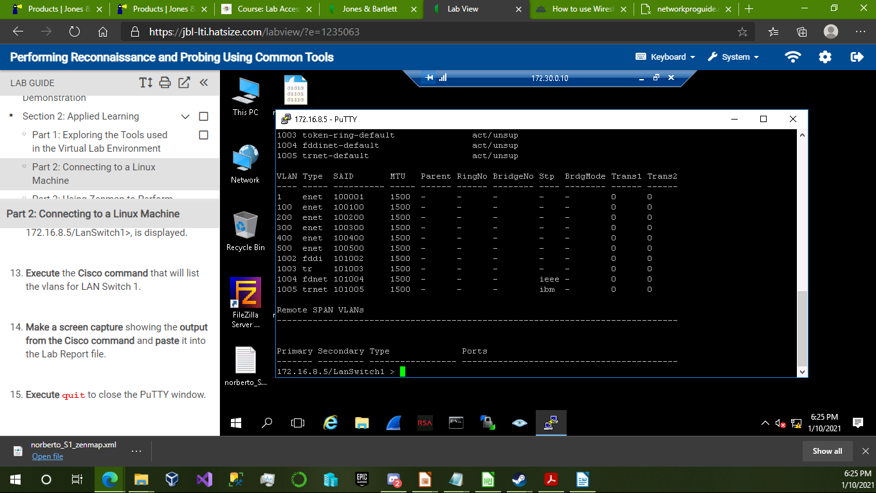

6. Fisheye Bubble chart from Zenmap scan:

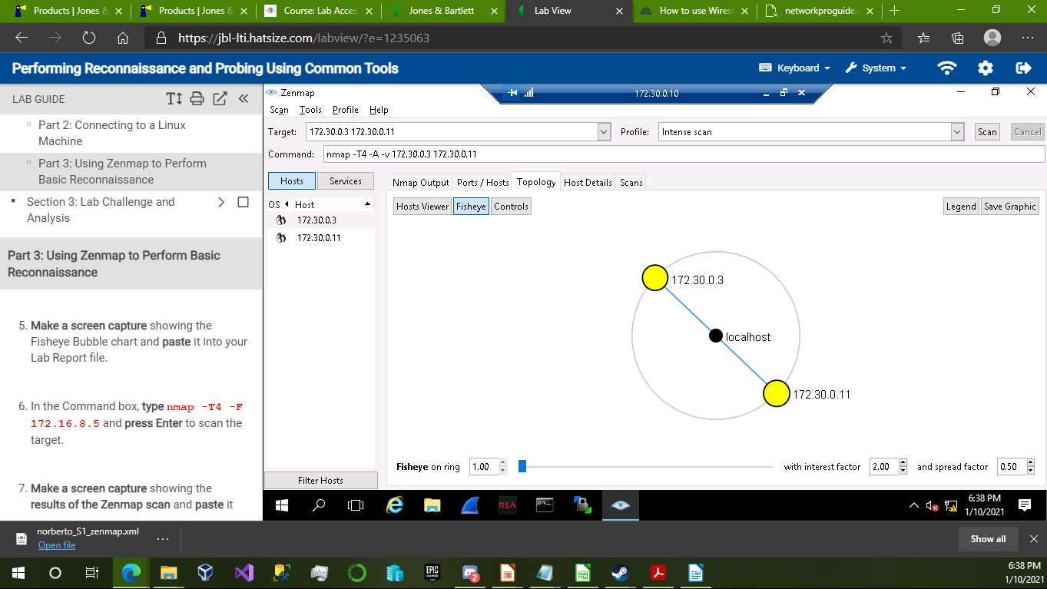

7. Results of the second Zenmap scan:

